[Insert organisation name/logo]

BASIC LIFE SUPPORT FLOW CHART

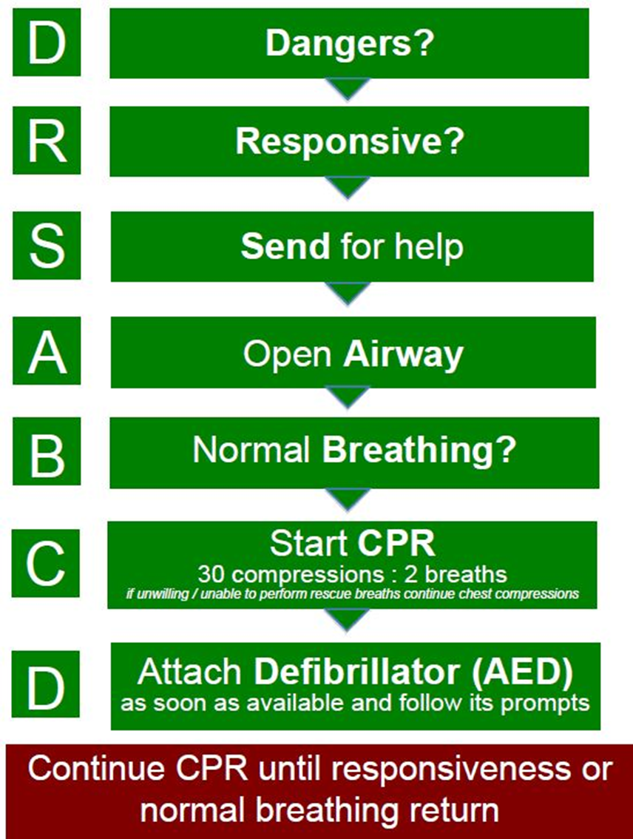

Note*
This chart is been adapted from The Australian Resuscitation Council. For more information on life support and resuscitation refer directly to their website http://www.resus.org.au/.

*Please delete note before finalising this document.

