[Insert organisation name/logo]

# ERGONOMIC OFFICE GUIDE

Although working in an office environment is deemed relatively safe, office workers face occupational hazards including the development of musculoskeletal injuries or discomfort associated with work.

The design of effective, safe work systems and processes (including ergonomic workspace, regular rest breaks and exercise) contributes to preventing office work related injuries.

## SECTION 1. RESPONSIBILTIES

### 1.1 [Insert organisation name]’s Responsibility

The organisation provides a safe environment for staff including safe equipment and guidance on safe procedures. It is the responsibility of all workers to use these consistently.

Regular review of policy, practices and procedures will occur particularly when processes change.

This guide includes direction on what staff and supervisors can do to help prevent overuse injuries, a checklist and selection of diagrams will direct **[Insert organisation name]** workers on how to create a safe, ergonomic work environment.

### 1.2 Employees Responsibility:

* **Take responsibility for personal behaviours**

These personal behaviours can work to improve general health, your response to other workers and work demands. Inform your supervisor promptly about any difficulties in relation to your work.

* **Postural breaks are essential**

Respond to feelings of fatigue or discomfort by changing task, changing posture or taking a break. Often your efficiency and concentration improve following such breaks.

* **Change your seated position frequently**

Make sure your feet rest on the floor or on a footrest and adjust the backrest occasionally for example to recline (when talking on the telephone). Ensure the backrest of your chair is supporting (presses in against) your lower back for most of the day.

* **Try standing occasionally**

Try reading with the file or book on the top of a filing cabinet; stand when talking on the telephone; remain standing when talking to other staff.

* **Extended leave precautions**

If you are absent from repetitive work for more than a month through illness, a change of duty or leave, resume a full workload gradually in consultation with your supervisor.

* **Short task breaks and stretches are recommended**

These should be taken at least once per hour and more frequently during intense keying periods. Regular opportunities to stand and walk are also important. Pause exercises can be performed throughout the day in some of these breaks to relieve muscular tension.

* **Take care never to over stretch to the point of experiencing pain.**

Take care to consult your treating practitioners if you have a medical condition for specific guidelines. Hold the stretches for approximately 10 to 15 seconds each.

***Remember, changing established postural habits can be uncomfortable in the short term. It is important to persist with such a change and be aware that your state of mind can cause increased muscular tension***

### 1.3 Supervisors Responsibility

Supervisors are responsible for the design of work to match human capacities. Attention needs to be given to the following factors in designing safe work:

1. Consultation with the workers regarding job design options
2. Rotation between a variety of tasks involving different muscles and joints
3. Plan staffing needs to cover foreseeable extremes of work pressure
4. Appropriate allocation of work during leave periods
5. Expectation to accommodate workers' reduced capacity following extended leave or injury
6. Consider rotation of tasks between workers
7. Equipment provision and maintenance

**What to do if discomfort arises?**

Early intervention to address health, safety or comfort concerns in the office environment is vital to ensuring the best chance at resolution and can only be achieved through effective communication between all parties. The Posture checklist section will help identify the limitations in the workplace that may be contributing to these concerns.

**Who is Responsible?**

Workers should report symptoms of discomfort early to their supervisors, and if necessary complete an Incident Report Form which will be reviewed and investigated by the Work Health and Safety (WHS) Officer. Late intervention can increase the risk of developing chronic musculoskeletal conditions.

**Development of Chronic conditions**

Chronic conditions may lead to a person being unable to maintain their employment despite subsequent changes to the tasks. This is necessary to prevent further risk for the staff member or other staff performing similar tasks.

## SECTION 2. STAFF WORKSTATION

Consider the diagram below, this shows the ideal layout of your workstation

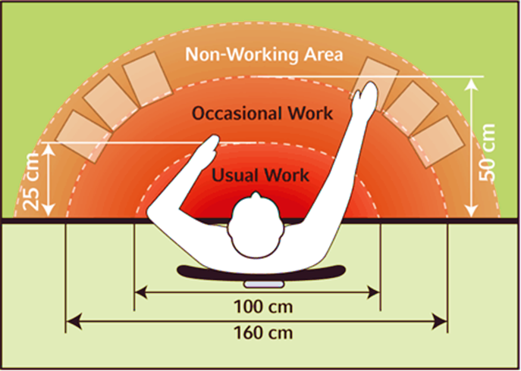

***How does your workstation match up?***

*Spend some time reorganising with this in mind*

### 2.1 Ergonomic guidelines for desktop computer

For workers using desktop computers, it is recommended to follow the image and guidelines below:

* Forearms should be parallel to the floor (approximately 900 angle at elbow)
* Upper arm and elbow should be as close to the body and as relaxed as possible
* Wrists should be as flat as possible (not bent up or down) and straight
* Mouse should be placed adjacent to keyboard and at the same height
* Monitor should be positioned directly in front of the user and at comfortable viewing distance (approximately 18-30” away, top of monitor 2-3” above eye level)
* Feet should be fully supported by a footrest or the floor

Follow the picture below to create an ergonomic space

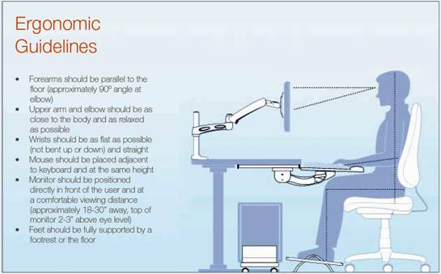

### 2.2 Ergonomic guidelines for a laptop computer

For workers using laptop computers, it is recommended to follow the image and guidelines below:

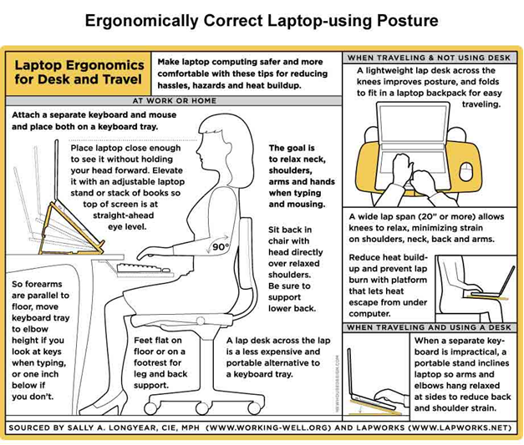

***Staff members are encouraged to use the checklist in the following section to see how their work habits and workstations are and to address any specific issues or actions***

## SECTION 3. CHECKLIST

Use the brief checklist below to check and correct your working habits and posture.

If you answer ***No*** to any of the questions discuss the action required with your supervisor. This may be referral to instructional resources or training.

|  |  |  |  |
| --- | --- | --- | --- |
| **Item** | **Yes** | **No** | **Action required** |
| Are your typing and mouse activities interspersed with a variety of other work tasks? | **□** | **□** |  |
| Are you including micro pauses as a deliberate attempt to reduce tension by relaxing between keyboard operations? E.g. relaxing the hands into the lap whilst waiting for a document to be saved? | **□** | **□** |  |
| Do you perform regular pause exercises during computer operation at least every hour including changing your visual focus? | **□** | **□** |  |
| Are you altering your seated posture regularly throughout the day? E.g. reclining whilst on the phone and sitting upright again to key? | **□** | **□** |  |
| Is your chair high enough or your desk low enough so that your elbows are level with or slightly higher than your keyboard while you type? | **□** | **□** |  |
| Does your chair have fully adjustable chair height, back rest position and seat tilt? | **□** | **□** |  |
| Do you have a stable footrest if your feet are not flat on the floor when sitting? | **□** | **□** |  |
| Does your desk provide adequate clearance for your legs to allow close access to the work task?  Minimum depth 900mm  Minimum width 1500mm | **□** | **□** |  |
| Is your chin tucked in towards the chest and aligned with the spine rather than poking forward or upwards? | **□** | **□** |  |
| Is the screen at a comfortable reading distance from the operator (350mm to 750mm)? | **□** | **□** |  |
| Is the image clear, stable and free from reflections and glare? | **□** | **□** |  |
| Are the monitor and keyboard aligned and directly in front of you so that you do not twist to reach the keys? | **□** | **□** |  |
| Is the keyboard located in close proximity to the body to avoid over reaching to key? | **□** | **□** |  |
| Are your frequently accessed items within easy reach whilst sitting and under 4kgs? | **□** | **□** |  |
| Are your shoulders relaxed when the hands are resting on the keys with the upper arms hanging naturally and the lower arm at approximately 90 degrees? | **□** | **□** |  |
| Are your wrists straight and in line with the forearm whilst keying or using the mouse, to avoid excessive bending to the side or upwards? | **□** | **□** |  |
| Is the mouse at the same level as the keyboard and used as close as possible to the keyboard to avoid stretching your arm out to the side or across the desk? | **□** | **□** |  |
| Do you have a relaxed grip when using the mouse? | **□** | **□** |  |
| Do you have a relaxed keying style and avoid finger stretching to reach keys? | **□** | **□** |  |
| Is the position of your source documents in line with or close to your monitor and around eye level to avoid excessive twisting or bending of your neck? | **□** | **□** |  |
| Does your desk top size easily accommodate all work tasks? ( minimum recommendations)  Computer and general clerical - 1500 X 900mm | **□** | **□** |  |
| Is your office lighting, noise level and temperature, conducive to your comfort and productivity? | **□** | **□** |  |
| For bi/tri/multi focal wearers is your monitor low enough to prevent you raising your chin to view the screen? | **□** | **□** |  |
| If you regularly experience eye fatigue have you had a recent review with your eye practitioner? Ensure you tell the practitioner the tasks you perform so the prescription is correct. | **□** | **□** |  |
| **[insert other item relevant to your organisation]** | **□** | **□** |  |

## SECTION 4. EXERCISES

The key to preventing overuse injuries is to break up the repetitive work with non-repetitive tasks or exercises and/or breaks.

Staff should move around to reduce the effects of fatigue by doing different tasks. And rest breaks should be taken if the task requires a sustained period of repetitive or static activity because task variation isn’t possible.

Staff is encouraged to use the following exercise sheets to prevent any work related injury while working for the organisation.

### 4.1 Pause exercise sheet one

**Stop, get up and move**

Getting up and walking around is the best exercise you can get to provide a break from sitting, concentrating and using the muscles of the arms and hands. About every 20 to 30 minutes is a guide to how often it is helpful to move around. Even getting up for 20 to 30 seconds to pick up papers from the photocopier or get some water is a way to change your posture and give muscles a chance to recover.

**Stretch and check!**

Stretching exercises help to relax muscles which have been working and move those which have been in a fixed position. If possible, stand up to do your stretches. While you are exercising, read the notes alongside each instruction and consider whether your workstation is adjusted to suit you.

|  |  |  |  |
| --- | --- | --- | --- |
| With elbows straight, grasp hand & slowly bend wrist back. Alternate hands. | ex1 | With elbows straight, grasp the hand & gently bend the wrist down. Alternate hands. | ex2 |
| Chin tucks  Raise the head to straighten the neck. Tuck the chin in and upwards creating a  double chin. |  | Shoulder rolls  Circle shoulders forward several times, then backwards. |  |
| Turn head slowly to look over the left shoulder. Return to the front. Turn head to look over the right shoulder. | ex3 | Tilt head gently to the left side & then to the right side. | ex4 |
| Stand, move and walk regularly.  Stand up, holding the chair for balance if necessary, & alternately raise heels & toes.  Repeat 10 times |  | Looking ahead, tuck chin in & hold. Relax & return to starting position. | ex6 |

### 4.2 Pause exercise sheet one

* These general pause exercises can help relieve muscular tension.
* Consult your doctor for specific guidelines if you have a medical condition
* Hold the stretches for 10 to 15 seconds each, taking care not to over stretch
* Repeat each movement 3 to 4 times

|  |  |  |  |
| --- | --- | --- | --- |
| With arms relaxed at side, roll your shoulders forwards then backwards. | **ex7** | Place hands on back  of hips & gently lean backwards. | ex8 |
| Interlace fingers and turn palms upwards above head; straighten arms then slowly lean slightly from side to side.  Repeat movement several times. |  | Raise both arms to shoulder height and bend elbows. Pull both elbows back slowly to bring shoulder blades towards each other. |  |
| Standing upright, draw both shoulders & elbow back & inward. | **ex9** | With feet apart, twist at the waist to the right then to the left using a slow smooth movement. | ex10 |
| Blink regularly  Look into the distance  Move your eyes horizontally, vertically and diagonally |  | Stretch arm above head and cradle elbow with hand. Gently pull elbow down behind the head. | ex12 |
| Source: Body Mechanics VHI Resource Library, Health Promotion Resources, 1999 | | | |

For more information and resources regarding Work Health and Safety refer to SafeWork NSW