[Insert organisation name/logo]

PHONE BOMB/CHEMICAL THREAT CHECKLIST

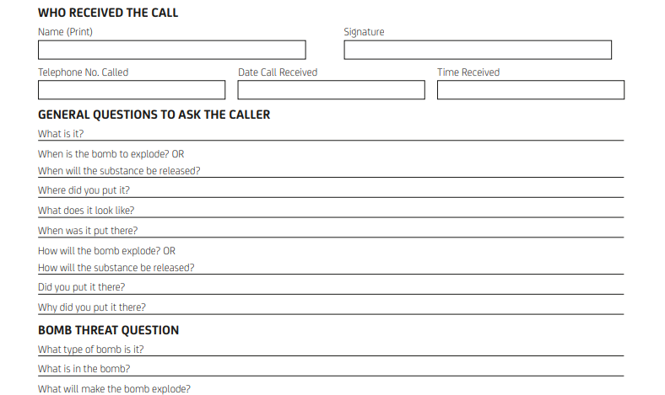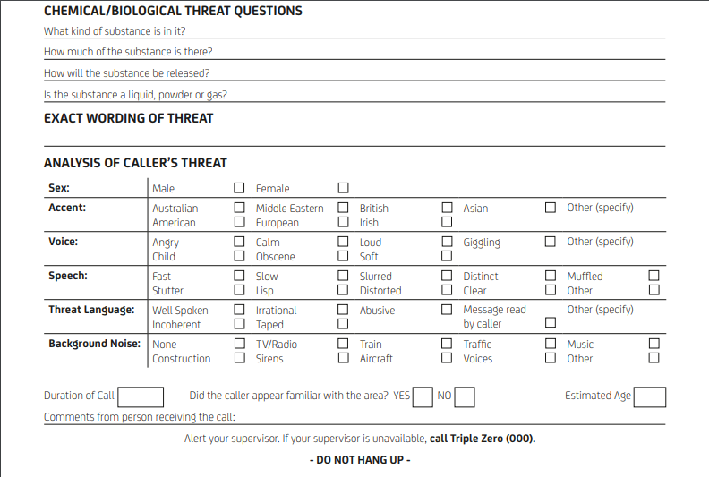

Contacts
[Insert organisation name] CEO | [Insert name] | [Insert phone number]
[Insert local police station] |  | [Insert alarm contractor phone number]

