[Insert organisation name/logo]

Disaster and Emergency Management Policy
Version: [Year/n]

Document status: Draft or Final

Date issued: [date]

Approved by: [insert organisation name] Board of Directors on [date]

Date for review: [date]

Record of policy development:

Version number | Date of issue | Lead author/ reviewer | Consultative panel | Significant changes on previous version
[Year/no] | [Date] | [Name/role] | [Name/role/ organisation] | [For example, incorporate changes to new legislation]

Note*
This policy template has been developed to meet the needs of a diverse range of services and includes items for consideration in policy and procedure. Thus, not all content will be relevant to your service. Organisations are encouraged to edit, add and delete content to ensure relevancy.

This template has undergone legal review through the generous assistance of a pro bono lawyer. However,
NADA does not take legal responsibility for how this policy template is used and implemented by organisations. Nor does the pro bono lawyer. You are welcome to seek independent legal advice if you would like to check the legal accuracy of this policy for your individual organisation.

All notes (like this one) should be considered and deleted before finalising the policy, and the contents list should be updated as changes are made and when content is finalised. See the NADA Policy Toolkit User Guide for more editing tips.

*Please delete note before finalising this policy.

Note*
To update the contents list when all content has been finalised, right click on the contents list and select ‘update field’, an option box will appear, select ‘Update entire table’ and ‘Ok’.

To use the contents list to skip to relevant text, use Ctlr and click to select the relevant page number.

*Please delete note before finalising this policy.
CONTENTS
Disaster and Emergency Management Policy 1
SECTION 1: Disaster and emergency management Policy 3
1.1 Policy Statement 3
1.2 Purpose and scope 3
1.3 Definitions 3
1.4 Principles 3
1.5 Outcomes 4
1.6 Roles and responsibilities 4
1.7 Policy implementation 5
1.8 Risk management 5
Section 2: Policy Detail 5
2.1 Risk Assessment 6
2.2 Preparedness 6
2.3 Response 7
Section 2: references 8
5.1 Internal References 8
5.2 External References 8

SECTION 1: Disaster and emergency management Policy

Policy Statement
Disasters and emergencies in the workplace can affect people physically and psychologically and disrupt program delivery continuity.

[Insert organisation name] identifies, prevents and manages disaster and emergency situations within its sphere of responsibility and influence, until the arrival of appropriate emergency services.

Purpose and scope
The purpose of this policy is to ensure the [insert organisation name] develops and maintains a capability, supported by effective risk-based arrangements, to prevent, prepare for, respond to, and recover from disasters and emergency events. The prevention and effective management of disaster and emergency situations can assist to minimise the negative impact of an unexpected event.
This policy applies to all staff, volunteers, Board members and students.

This policy does not provide detailed guidance on:
- Risk management processes – refer to Risk Management Policy and Procedure.
- developing and implementing work health and safety (WHS) systems, and responding to health and safety risks and incidents– refer to the Work Health and Safety Policy and Procedure.

Definitions

[Insert organisation name] Staff | Comprises of all professional staff employed by [insert organisation name], not including the board, students and volunteers.
Emergency | An unplanned or imminent event that affects or threatens the health, safety or welfare of people, property and infrastructure, and which requires a significant and coordinated response. The defining characteristic of an emergency event or situation is that usual resources are overwhelmed or have the potential to be overwhelmed.  Emergencies may be a specific event with a clear beginning, end and recovery process, or a situation that develops over time and where the implications are gradual rather than immediate.
Disaster | A condition or situation of significant destruction, disruption and/or distress to a community.
Emergency management | The coordination of an emergency response and management of recovery. The aim of emergency management is to minimise physical and psychological impacts on all parties and to minimise damage to assets, operations, reputation and staff productivity.

1.4 Principles
This policy aims to:
- Ensure disaster and emergency management planning is being prepared for events or incidents that stretch our ability to cope beyond normal day-to-day capacity.
- Show the organisation is committed to the protection of clients, staff, volunteers, Board members, students, visitors and the community during disasters and emergencies.
- Enable [insert organisation name] to swiftly and effectively respond to disaster and emergency situations, with the foremost goal of preserving life and then, protecting the organisation’s property, and restoring operations as quickly as possible.

1.5 Outcomes
- Emergency situations are prevented as far as practical.
- The negative impact of emergency and disaster situations is minimised through effective management.

1.6 Roles and responsibilities

[Organisation name] Board | - Endorse Disaster and Emergency Management Policy.  - Comply with Disaster and Emergency Management Policy.  - Monitor disaster and emergency management strategies and incidents.
Business Services/Management | - Comply with Disaster and Emergency Management Policy.  Ensure compliance with the Disaster and Emergency Management Policy.  - Ensure staff are provided with relevant training relating to disaster and emergency management, such as fire response and first aid training.  - Lead emergency responses where the delegated WHS Representative is not available.  CEO/Manager  - Operational decision-making relating to disaster and emergency management, including expenditure  - Refer serious disaster and emergency events to the Board and/or relevant authorities.
Clinical, program and other staff | - Comply with Disaster and Emergency Management Policy.  Work, Health and Safety (WHS) Representative  - Representation of [insert organisation name] workers in the workplace.  - Maintain Disaster and Emergency Management records.  - Investigate disaster and emergency management incidents, and make recommendations to [insert organisation name] Board in relation to these incidents and related systems.  - Undertake relevant training  Fire Safety Officer  - Lead emergency evacuations and evacuation drills.  - Supervises day-to-day fire prevention, protection, fire safety functions and implement emergency procedures.  - Make recommendations to improve emergency evacuation and fire safety policy and practice.  - Undertake relevant training  First Aid Officer  - Lead First Aid responses.  - Monitor and maintain First Aid facilities  - Make recommendations to improve First Aid policy and practice.  - Undertake relevant training

*Note
Examples of training for the Fire Safety Officer and First Aid Officer roles include training by Fire Safety Australia and St John’s Ambulance respectively.
*Remove this note before finalising this document.

1.7 Policy implementation
This policy is developed in consultation with [insert organisation name] staff and endorsed by the [organisation name] Board. Staff are responsible for understanding and adhering to this Policy.

1.8 Risk management
This Policy is informed by and complies with relevant legislation, including the
  - Work Health and Safety Act 2011 (Cth); and
  - the Work Health and Safety Regulations 2011 (Cth).

All Board members and staff are informed about disaster and emergency response procedures at induction by their supervisor and/or WHS Representative.

Emergency evacuation drills are undertaken in sites [insert regularity]. The Disaster and emergency management plan is reviewed [insert regularity] and/or following the event of a disaster or emergency situation.

Section 2: Policy Detail
[Insert organisation name] identifies, prevents and manages disaster and emergency situations within its sphere of responsibility and influence, until the arrival of appropriate emergency services. [Insert organisation name] think of disasters and emergencies as recurring events with four phases: prevention, preparedness, response, and recovery- illustrated in the diagram below:

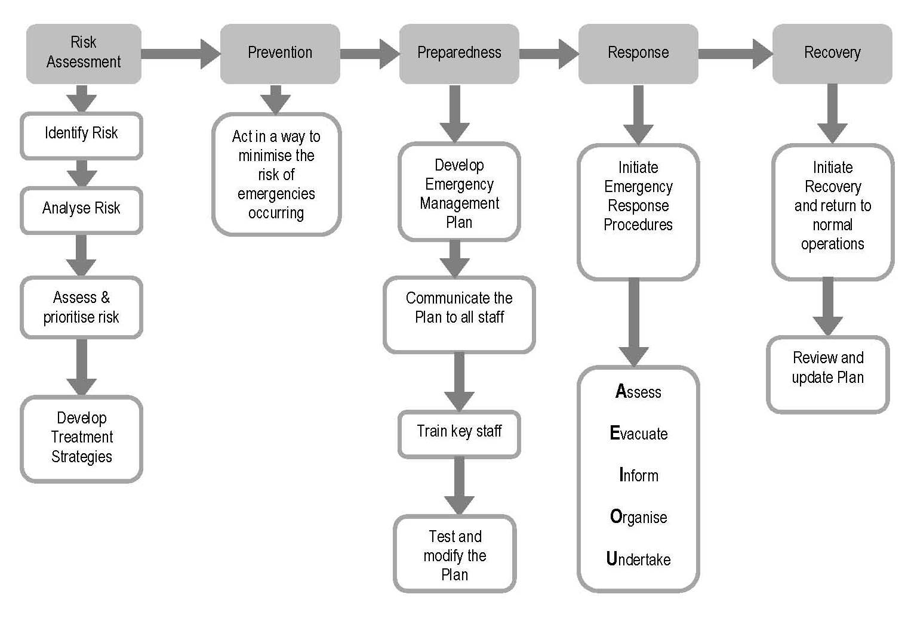
A range of disasters and emergencies may occur on the premises with the potential to impact the safety of staff, Board members, volunteers, students, visitors and clients, including:

- fire
- gas or water leak
- Cyber threats
- chemical, radiation or biological spill
- storm
- earthquake
- bomb threat
- civil disorder or illegal occupancy
- hostage or terrorist situation
- an infestation, plague, epidemic or pandemic
- a failure of, or disruption to, an essential service or infrastructure.

2.1 Risk Assessment
[Insert organisation name] uses risk assessment processes to identify and control barriers to effective emergency management. Refer to the Risk Management Policy and Procedure.

Staff, Board members, students, volunteers and clients are expected to behave in a way to minimise the risk of emergencies occurring.

2.2 Preparedness
The Emergency Situation Checklist supports the organisation to prepare for potential disaster and emergency situations, and is reviewed an [insert frequency] basis as per organisational policy and best practice. The Disaster and emergency management plan is reviewed on an [insert frequency] basis.

All staff, Board members, students and volunteers are provided with orientation or training to ensure they are familiar with implementation of the Disaster and emergency management plan. Training undertaken is tracked and reviewed regularly.

Employees acting as a WHS Representative, First Aid Officer, or Fire Safety Officer are required and supported to undertake training as part of their roles.

All staff, Board members, students and volunteers familiarise themselves with emergency evacuation procedures, including their responsibilities and the emergency evacuation assembly point.

All fire safety activities undertaken by the organisation are recorded and reviewed to identify gaps in training, knowledge or processes. Fire activities include, but are not limited to, fire safety training, evacuation and training drills and exercises, records of maintenance and inventories of equipment kept.

2.3 Response
When a disaster or emergency situation arises, the primary aim of the response is to ensure the safety of all people on the premises, preserve life and protect property.

Procedures for responding to fire, hold-up, cyber security and information technology threats, bomb threat, flood, earthquake, suspicious mail and an epidemic or pandemic are outlined in the Disaster and emergency management plan. You can refer to the ‘Australian Health Management Plan for Pandemic Influenza’ and CovidSafe Plans and Guidance in the external references section of this policy for further guidance on how to develop your procedural response to pandemics and epidemics.

2.4 Recovery

[Insert organisation name] initiates recovery and aims to restore operations as quickly as possible. Following an emergency, the Fire Safety Officer, WHS Representative and CEO/Manager are to review the emergency event with the view of implementing improvements in overall WHS and emergency management.
The Disaster and Emergency Management Plan provides space for a Business Impact Assessment to be conducted as part of the recovery process.

Section 2: references

5.1 Internal References
Policy and procedure:
- Work Health and Safety Policy and Procedure
- Risk Management Policy and Procedure
Supporting documents:
- Emergency Situation Checklist
- Disaster and emergency management plan
- Emergency Evacuation Report

5.2 External References

5.2.1 Legislation
- Work Health and Safety Act 2011 (Cth)
- Privacy Act 1988 (Cth)
- Health Records and Information Privacy Act 2002 (NSW)
- Privacy and Personal Information Protection Act 1998 (NSW)

5.2.2 Resources
- WorkCover NSW 2004, The Community Services Safety Pack: A Guide to Occupational Health & Safety. Gosford, NSW.
- Australian Charities and Not-For-Profits Commission, Governance Toolkit: Cyber Security, viewed 11 October 2023, https://www.acnc.gov.au/for-charities/manage-your-charity/governance-hub/governance-toolkit/governance-toolkit-cyber-security
- Australian Health Management Plan for Pandemic Influenza (AHMPPI), viewed 11 October 2023, https://www.health.gov.au/resources/publications/australian-health-management-plan-for-pandemic-influenza-ahmppi?language=en
- CovidSafe Plans/Guidance:
ACT – Australian Capital Territory: https://www.act.gov.au/business/keeping-your-business-covid-safe
NSW – New South Wales: https://www.nsw.gov.au/covid-19/business/safety-plans

5.2.3 Websites
- Safe Work Australia: www.safeworkaustralia.gov.au
- WorkCover Authority of NSW website: www.workcover.nsw.gov.au
- Australian Government Business: https://www.business.gov.au/

